UPDATES PROMPT

General
There is too much syncing going on, update to minimize sync only after startup and changes being made.

In Desktop browser, Board view:
Projects rearrange by drag and drop does not work.
for quick task add while filters are on, the new task will receive the filters that are on.

In Desktop browser, Table view:
Remove redundant print button above flag column header. Align the flag task icons below the column header text.
Add another new flag type ‘sampled’ with yellow light bulb icon , the idea is that if I mark it then it means I am dealing with the tasks. Add a filter called ‘Not Sampled’, hitting this filter will show all task that were not marked as sampled. This flag should be selected by default. Each day, in 07:00am, all ‘sampled’ task flags are cleared. Implement for browser and IOS. Print preview by default should be fitted to 1 page horizontally.

In Desktop browser, Focus view:
everything looks and works great
Add another new flag type ‘sampled’ with yellow light bulb icon , the idea is that if I mark it then it means I am dealing with the tasks. Add a filter called ‘Not Sampled’, hitting this filter will show all task that were not marked as sampled. This flag should be selected by default. Each day, in 07:00am, all ‘sampled’ task flags are cleared. Implement for browser and IOS. Add buttons to expand/collapse tasks and projects, similar to Board view.
Print preview by default should be fitted to 1 page horizontally.

In Desktop browser, Projects Summary view:
HEALTH bar should be change to PROGRESS bar, it should show elapsed specific project progress based on this project start/finish date that is entered by user in Project Info view for this project. Check why project start/finish date I entered in Projects Info view are not saved and updated for this progress bar to show.
Add a combo box to choose a project to filter and show. The items in the combo box should show Account / Project name (with related color code).
Change Milestone input text should include 2 fields: Milestone Description (Text), Sales Amount (K USD).
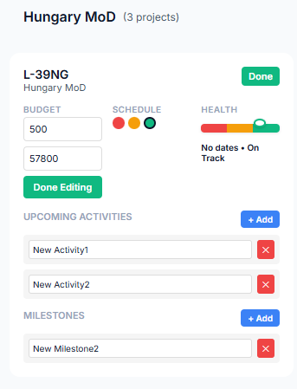

Print preview by default should be fitted to 1 page horizontally.

In Desktop browser, Projects Info view:
Add a combo box to choose a project to filter and show. The items in the combo box should show Account / Project name (with related color code).
Print preview by default should be fitted to 1 page horizontally.

In IOS, Board view:
Verify that every feature in browser is supported and convenient in IOS

In IOS, Table view:
Verify that every feature in browser is supported and convenient in IOS

In IOS, Focus view:
Verify that every feature in browser is supported and convenient in IOS

In IOS, Projects Summary view:
Verify that every feature in browser is supported and convenient in IOS

In IOS, Projects Info view:
Verify that every feature in browser is supported and convenient in IOS

TASK HIVE UPDATES
- Kanban view doesn’t work anymore
- In table view – no need to have open button to projects
- Drag and drop reorder tasks within same project – not working
- In Table View - add option to collapse account and project – collapse/show all accounts level, collapse/show all projects level
- In Table View - improve the way subtasks are presented – subtasks not showing at all, fix
- In Table View - improve the way subtasks are presented, add option to mark complete subtasks
- In all views - add option to clear flags - fixed
- In Kanban view - hide accounts or project that don't show tasks due to flags being applied - fixed
- In Project Info - under Basic Information, add fields Project Start Date, Project Start Date (field type date with date picker) - fixed
- In Project info - show all accounts side by side and the projects below each account with scroll up/down, if doesn't fit the screen allow scroll up/down under each account
- In Kanban view - show all accounts side by side and the projects below each account, if doesn't fit the screen arrange projects on after other top/down
- In Kanban view - if any account / project doesn't have tasks under it showing (in case no tasks or filtered out by flags), hide it.
- In all views allow drag and drop reorder accounts - fixed
- In Kanban and Table views - the flags area is fixed and is not affected by scrolling down - fixed
- on top area rearrange - All tasks, Today, Follow-up, Urgent - fixed
- leave only 1 instance of flags – on tope area next to project info tab
- In table view, flags column doesn’t show values – still not showing
- Remove Progress column – fixed
- Update everything in TaskHive_Functional_Specification

